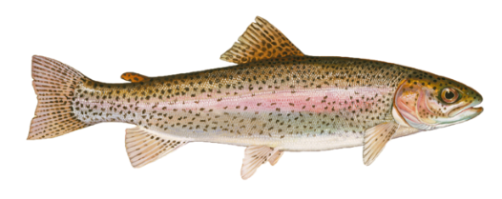
Quapaw Fishing Terms

ho – fish
ni – water
watʰíška – creek, river
ni sákki – water rapids, current in moving water
ho wébaxto – fish spear
ho wékixe – fishing net
ho wébitti – fishing weir

Types of Fish

ho bdóka – sucker fish
ho tté hóšoka – trout
ho ppási stétte – gar fish
ho dátte – freshwater drum fish
ho ttáma – dogfish (bowfin)
ho stétte - eel
ppasí odokáhi - spoonbill
ho ką́ni – buffalo fish (ictiobus)
mixé – Black Bullhead catfish
ttoze – mud catfish
mixé ha sáki – white catfish
mižą́į – Yellow Bullhead catfish

Parts of a Fish
ho šókka – fish bladder
ho ppízi – fish gall bladder
ho ppí – fish liver
ho šénąkke – fish scales
ho ištá – fish eyes
ho íbe – tail fin

